**DIARGAM DATABASE FOR PROJECT**

**SMARTHOMECARE**

**1/** Module **User Account & Registration**

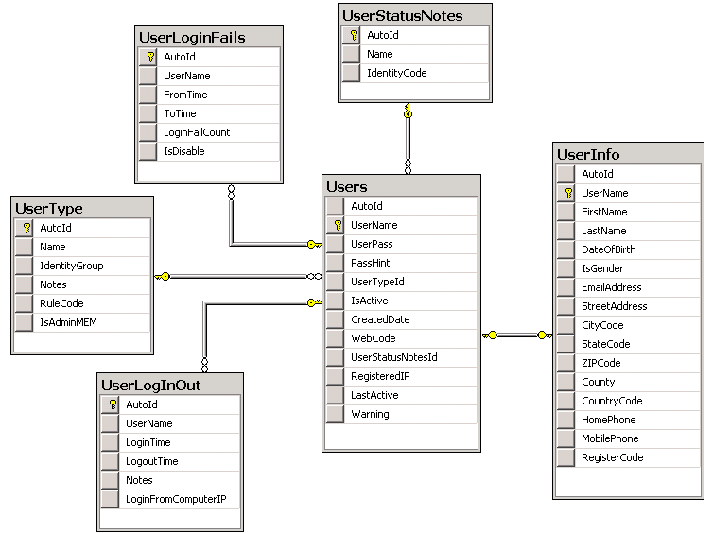

Description: *only desciption tables primary*

Table **Users:** save the information about user account when user created a acount

|  |  |  |  |
| --- | --- | --- | --- |
| **No.** | **Field name** | **Data type** | **Notes** |
| 1 | AutoId | int | Automatic increase |
| 2 | UserName | varchar (50) | Primary key |
| 3 | UserPass | varbinary (50) |  |
| 4 | PassHint | varchar (50) |  |
| 5 | UserTypeId | int | Foreign key from table UserType |
| 6 | IsActive | bit |  |
| 7 | WebCode | varchar (50) | When you created account then system will sent link to your e-mail, and you must login and click link in your e-mail. And, your account will activated immediately. After, you can login website normal |
| 8 | UserStatusNotesId | int | Foreign key table UserStatusNotes |
| 9 | RegisteredIP | varchar (50) | Computer IP when login to website |
| 10 | LastActive | datetime |  |
| 11 | Warning | varchar (50) |  |

Table **UserInfo:** mangementthe information personal details of user when user created an account

|  |  |  |  |
| --- | --- | --- | --- |
| **No.** | **Field name** | **Data type** | **Notes** |
| 1 | UserName | varchar (50) | Primary key, the same with table Users |
| 2 | FirstName | varchar (50) |  |
| 3 | LastName | varchar (50) |  |
| 4 | DateOfBirth | date |  |
| 5 | IsGender | bit |  |
| 6 | EmailAddress | varchar (50) |  |
| 7 | StreetAddress | varchar (50) |  |
| 8 | CityCode | varchar (50) |  |
| 9 | StateCode | varchar (10) |  |
| 10 | ZIPCode | varchar (50) |  |
| 11 | County | varchar (50) |  |
| 12 | CountryCode | varchar (50) |  |
| 13 | HomePhone | varchar (50) |  |
| 14 | MobilePhone | varchar (50) |  |
| 15 | RegisterCode | varchar (50) | Primary/Foreign key in table RegisterCodes. Here is code that user input in textbox when user assign new account. It is only one (All user will not duplicate this code in system website). |

**2/**Module **Registration:** mangement RegisterCode of user

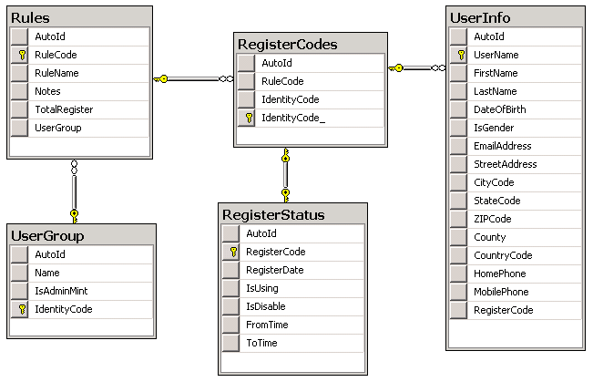

Table **Rules:** mangementrules of user, as: MON/PAR/PRI – Monitor/Partail/Primary

|  |  |  |  |
| --- | --- | --- | --- |
| **No.** | **Field name** | **Data type** | **Notes** |
| 1 | RuleCode | varchar (50) | Primary key |
| 2 | RuleName | varchar (50) |  |
| 3 | ToatlRegister | int | Quantity RegistorCode of every RuleCode |
| 4 | UserGroup | varchar (50) | Foreign key in table UserGroup |

Table **RegisterCodes:** mangementlist RegisterCode used to assign every account of user when them registry. Normal, system is created default this codes /or input manual, and after, every code will set to account of user. You will been specify permission to browser website from RegisterCode.

|  |  |  |  |
| --- | --- | --- | --- |
| **No.** | **Field name** | **Data type** | **Notes** |
| 1 | RuleCode | varchar (50) | Foreign key in table Rules |
| 2 | IdentityCode | varchar (50) | Code will created automatic |
| 3 | IdentityCode_ | varchar (50) | Primary key, combine from RuleCode and IdentityCode, by formula **[RoleCode.IdentityCode]** |

Table **RegisterStatus:** mangementstatus RegisterCode of user

|  |  |  |  |
| --- | --- | --- | --- |
| **No.** | **Field name** | **Data type** | **Notes** |
| 1 | RegisterCode | varchar (50) | Primary key |
| 2 | RegisterDate | datetime | Registry date |
| 3 | IsUsing | bit | Specify RegisterCode is using or not using |
| 4 | IsDisable | bit | Specify RegisterCode is disable or not disable |
| 5 | FromTime | datetime | From time when RegisterCode is disable |
| 6 | ToTime | datetime | To time when RegisterCode is disable |

**3/** Module **Billing**

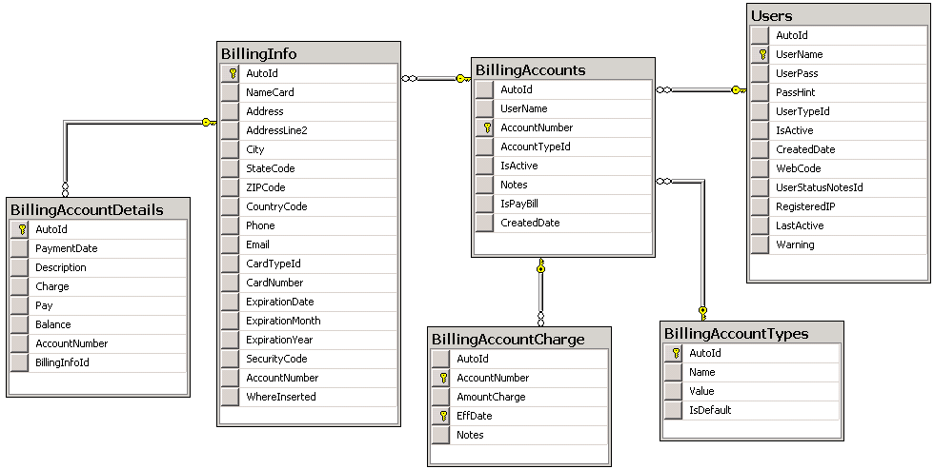

Table **BillingAccounts:** mangementthe information account payment of user. When user created an account of user successful then system will created an account payment of user. Now, system is had desgning expand (user have many account payment)

|  |  |  |  |
| --- | --- | --- | --- |
| **No.** | **Field name** | **Data type** | **Notes** |
| 1 | UserName | varchar (50) | Foreign key from table Users |
| 2 | AccountNumber | varchar (50) | Primary key |
| 3 | AccountTypeId | int |  |
| 4 | IsActive | bit |  |
| 5 | Notes | varchar (200) |  |
| 6 | IsPayBill | bit | Allow system automatic payment |
| 7 | CreatedDate | datetime |  |

Table **BillingInfo:** mangementthe information address of user when user performance a transaction payment, as: address, phone, e-mail,…

|  |  |  |  |
| --- | --- | --- | --- |
| **No.** | **Field name** | **Data type** | **Notes** |
| 1 | NameCard | varchar (50) |  |
| 2 | Address | varchar (200) |  |
| 3 | AddressLine2 | varchar (200) |  |
| 4 | City | varchar (50) |  |
| 5 | StateCode | varchar (10) |  |
| 6 | ZIPCode | varchar (50) |  |
| 7 | CountryCode | varchar (10) |  |
| 8 | Phone | varchar (50) |  |
| 9 | Email | varchar (50) |  |
| 10 | CardTypeId | int |  |
| 11 | CardNumber | varchar (50) |  |
| 12 | ExpirationDate | varchar (10) |  |
| 13 | ExpirationMonth | int |  |
| 14 | ExpirationYear | int |  |
| 15 | SecurityCode | varchar (50) |  |
| 16 | AccountNumber | varchar (50) | Foreign key from table BillingAccounts |
| 17 | AutoId | int | Primary key |

Table **BillingAccountDetails:** mangementhistory a transaction payment of every BillingInfor, include by user or automatic

|  |  |  |  |
| --- | --- | --- | --- |
| **No.** | **Field name** | **Data type** | **Notes** |
| 1 | PaymentDate | datetime | Payment date |
| 2 | Description | varchar (200) |  |
| 3 | Charge | float | Money charge (by auto of system) |
| 4 | Pay | float | Money pay (by user) |
| 5 | Balance | float | Money balance |
| 6 | AccountNumber | varchar (50) |  |
| 7 | BillingInfoId | int | Foreign key from table BillingInfo |

Table **BillingAcountCharge:** mangementmoney charge of user from setting. When system performance automatic a transaction then money charge will been get data from this table of an account of user

|  |  |  |  |
| --- | --- | --- | --- |
| **No.** | **Field name** | **Data type** | **Notes** |
| 1 | AccountNumber | varchar (50) | Foreign key from table BillingAccounts |
| 2 | AmountCharge | float | Money charge |
| 3 | EffDate | date | Effective date to apply payment. When payment automatic, system will filter newest date with current date |
| 4 | Notes | varchar (200) |  |

**4/** Module **Temperature:** management setting information and receive Temperature data from BS

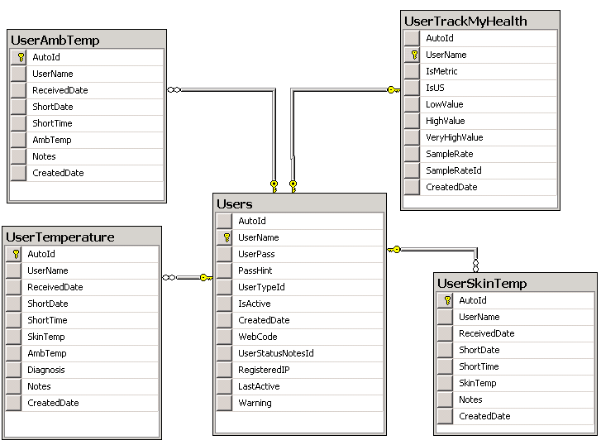

Table **UserTrackMyHealth**: management setting Temperature

|  |  |  |  |
| --- | --- | --- | --- |
| **No.** | **Field name** | **Data type** | **Notes** |
| 1 | UserName | varchar (50) | Foreign key from table Users |
| 2 | IsMetric | bit |  |
| 3 | IsUS | bit |  |
| 4 | LowValue | float |  |
| 5 | HighValue | float |  |
| 6 | VeryHighValue | float |  |
| 7 | SampleRate | float |  |
| 8 | SampleRateId | int | Foreign key from table UnitTime |
| 9 | CreatedDate | datetime |  |

Table **UserTemperature**: management and receive Temperature data from BS

|  |  |  |  |
| --- | --- | --- | --- |
| **No.** | **Field name** | **Data type** | **Notes** |
| 1 | UserName | varchar (50) | Foreign key from table Users |
| 2 | ReceivedDate | datetime | Receive date data Temperature of User from BS device |
| 3 | SkinTemp | float | Receive data Temperature Skin of User from BS device |
| 4 | AmbTemp | float | Receive data Temperature Ambient of User from BS device |
| 5 | Diagnosis | varchar (300) | Receive data diagnosis of users User from BS device |
| 6 | Notes | varchar (50) |  |
| 7 | CreatedDate | datetime |  |

Table **UserAmbTemp**: management Temperature Ambient and receive data from BS

|  |  |  |  |
| --- | --- | --- | --- |
| **No.** | **Field name** | **Data type** | **Notes** |
| 1 | UserName | varchar (50) | Foreign key from table Users |
| 2 | ReceivedDate | datetime | Receive date data Temperature of User from BS device |
| 3 | AmbTemp | float | Receive data Temperature Amb of User from BS device |
| 4 | Notes | varchar (50) |  |
| 5 | CreatedDate | datetime |  |

Table **UserSkinTemp**: management Temperature Skin and receive data from BS

|  |  |  |  |
| --- | --- | --- | --- |
| **No.** | **Field name** | **Data type** | **Notes** |
| 1 | UserName | varchar (50) | Foreign key from table Users |
| 2 | ReceivedDate | datetime | Receive date data Temperature of User from BS device |
| 3 | SkinTemp | float | Receive data Temperature Skin of User from BS device |
| 4 | Notes | varchar (50) |  |
| 5 | CreatedDate | datetime |  |

**6/** Module **BodyMeasurement:** management setting information Body of user



Table **BodyMeasurement:**

|  |  |  |  |
| --- | --- | --- | --- |
| **No.** | **Field name** | **Data type** | **Notes** |
| 1 | UserName | varchar (50) | Foreign key from table Users |
| 2 | IWTypeId | int | Foreign key from table BodyIWType |
| 3 | BFTypeId | int | Foreign key from table BodyBFType |
| 4 | BMRTypeId | int | Foreign key from table BodyBMRType |
| 5 | FatEvalId | int | Foreign key from table BodyFatEval |
| 6 | ActivityFactorTypeId | int | Foreign key from table BodyActivityFactorType |
| 7 | Weight | float | Standard format of US |
| 8 | Height | float | Standard format of US |
| 9 | HeightFeet | float | Convert from Height of US |
| 10 | HeightInch | float | Convert from Height of US |
| 11 | Waist | float | Standard format of US |
| 12 | Hip | float | Standard format of US |
| 13 | Neck | float | Standard format of US |
| 14 | Weight0 | float | Standard format of Metric |
| 15 | Height0 | float | Standard format of Metric |
| 16 | Waist0 | float | Standard format of Metric |
| 17 | Hip0 | float | Standard format of Metric |
| 18 | Neck0 | float | Standard format of Metric |
| 19 | CreatedDate | datetime |  |

**7/** Module **Fitness:**

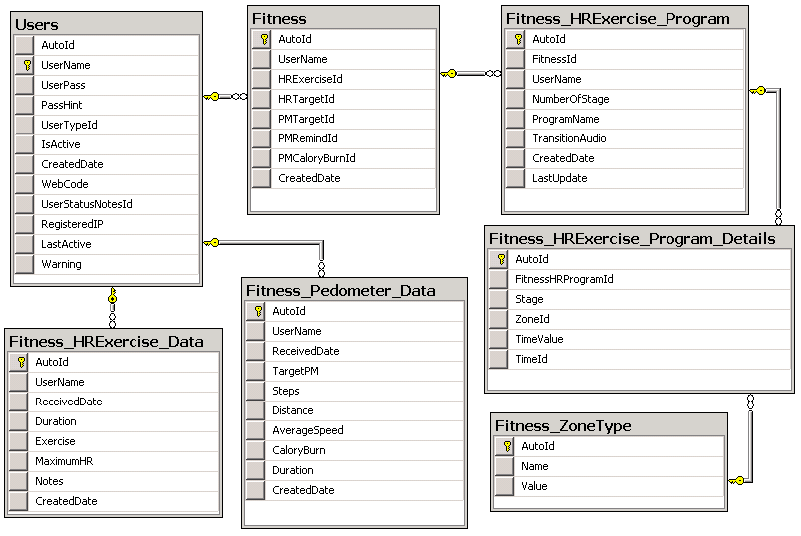

Table **Fitness**: management setting information Fitness by setting of User and receive data from BS

|  |  |  |  |
| --- | --- | --- | --- |
| **No.** | **Field name** | **Data type** | **Notes** |
| 1 | UserName | varchar (50) | Foreign key from table Users |
| 2 | HRExerciseId | int | Foreign key from table Fitness_HRExerciseType |
| 3 | HRTargetId | int | Foreign key from table Fitness_HRTargetType |
| 4 | PMTargetId | int | Foreign key from table Fitness_PMTargetType |
| 5 | PMRemindId | int | Foreign key from table Fitness_PMRemindType |
| 6 | PMCaloryBurnId | int | Foreign key from table Fitness_PMCaloryBurnType |
| 7 | CreatedDate | datetime |  |

Table **Fitness_HRExercise_Program**: management setting information HRExercise Program of user

|  |  |  |  |
| --- | --- | --- | --- |
| **No.** | **Field name** | **Data type** | **Notes** |
| 1 | FitnessId | int | Foreign key from table Fitness |
| 2 | UserName | varchar (50) | Foreign key from table Users |
| 3 | NumberOfStage | int |  |
| 4 | ProgramName | varchar (50) |  |
| 5 | TransitionAudio | varchar (50) |  |
| 6 | LastUpdate | datetime |  |
| 7 | CreatedDate | datetime |  |

Table **Fitness_HRExercise_Program_Details:** management setting information HRExercise Program of Stages of Fitness

|  |  |  |  |
| --- | --- | --- | --- |
| **No.** | **Field name** | **Data type** | **Notes** |
| 1 | FitnessHRProgramId | int | Foreign key from table Fitness_HRExercise_Program |
| 2 | Stage | varchar (50) |  |
| 3 | ZoneId | int | Foreign key from table Fitness_ZoneType |
| 4 | TimeValue | float |  |
| 5 | TimeId | int | Foreign key from table Users |

Table **Fitness_HRExercise_Data:** management receive HRExercise data of User from BS

|  |  |  |  |
| --- | --- | --- | --- |
| **No.** | **Field name** | **Data type** | **Notes** |
| 1 | UserName | int | Foreign key from table Users |
| 2 | ReceivedDate | datetime |  |
| 3 | Duration | float |  |
| 4 | Exercise | varchar (10) |  |
| 5 | MaximumHR | int |  |
| 6 | Notes | varchar (200) |  |
| 7 | CreatedDate | datetime |  |

Table **Fitness_Pedometer_Data**: management Pedometer and receive data of User from BS

|  |  |  |  |
| --- | --- | --- | --- |
| **No.** | **Field name** | **Data type** | **Notes** |
| 1 | UserName | varchar (50) | Foreign key from table Users |
| 2 | ReceivedDate | datetime |  |
| 3 | TargetPM | float |  |
| 4 | Steps | float |  |
| 5 | Distance | float |  |
| 6 | AverageSpeed | float |  |
| 7 | CaloryBurn | float |  |
| 8 | Duration | float |  |
| 9 | CreatedDate | datetime |  |

**8/** Module **Heart Rate:** management setting information Heart Rate by setting of User and receive data from BS

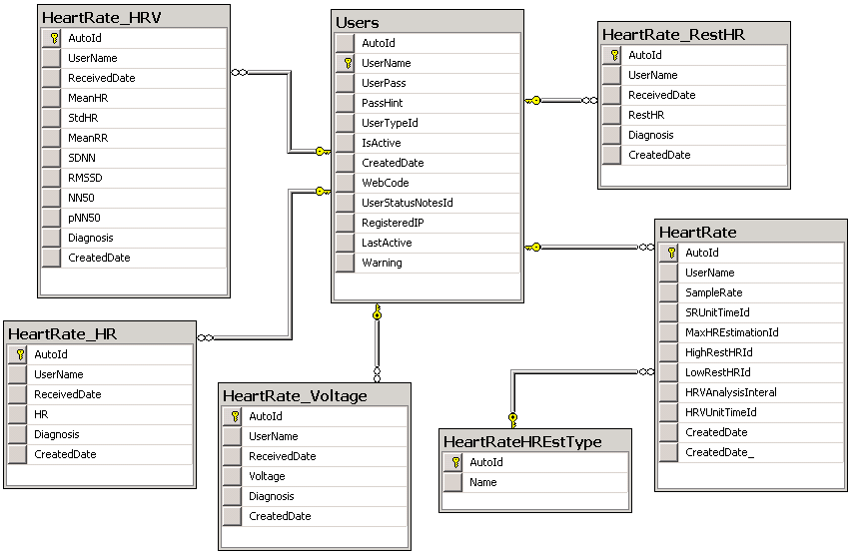

Table **HeartRate:** management setting information HeartRate of User

|  |  |  |  |
| --- | --- | --- | --- |
| **No.** | **Field name** | **Data type** | **Notes** |
| 1 | UserName | varchar (50) | Foreign key from table Users |
| 2 | SampleRate | float |  |
| 3 | SRUnitTimeId | int | Foreign key from table UnitTime |
| 4 | MaxHREstimationId | int |  |
| 5 | HighRestHRId | int | Foreign key from table UnitBPM |
| 6 | LowRestHRId | int | Foreign key from table UnitBPM |
| 7 | HRVAnalysisInteral | float |  |
| 8 | HRVUnitTimeId | int | Foreign key from table UnitTime |
| 9 | CreatedDate | datetime |  |

Table **HeartRate_HRV:** management receive data HRV from BS of user

|  |  |  |  |
| --- | --- | --- | --- |
| **No.** | **Field name** | **Data type** | **Notes** |
| 1 | UserName | varchar (50) | Foreign key from table Users |
| 2 | ReceivedDate | datetime |  |
| 3 | MeanHR | float |  |
| 4 | StdHR | float |  |
| 5 | MeanRR | float |  |
| 6 | SDNN | float |  |
| 7 | RMSSD | float |  |
| 8 | NN50 | float |  |
| 9 | pNN50 | float |  |
| 10 | Diagnosis | varchar (200) |  |
| 11 | CreatedDate | datetime |  |

Table **HeartRate_HR:** management receive data HRV from BS of user

|  |  |  |  |
| --- | --- | --- | --- |
| **No.** | **Field name** | **Data type** | **Notes** |
| 1 | UserName | varchar (50) | Foreign key from table Users |
| 2 | ReceivedDate | datetime |  |
| 3 | HR | float |  |
| 4 | Diagnosis | varchar (200) |  |
| 5 | CreatedDate | datetime |  |

Table **HeartRate_Voltage:** management receive data Voltage from BS of user

|  |  |  |  |
| --- | --- | --- | --- |
| **No.** | **Field name** | **Data type** | **Notes** |
| 1 | UserName | varchar (50) | Foreign key from table Users |
| 2 | ReceivedDate | datetime |  |
| 3 | Voltage | float |  |
| 4 | Diagnosis | varchar (200) |  |
| 5 | CreatedDate | datetime |  |

Table **HeartRate_RestHR:** management receive data RestHR from BS of user

|  |  |  |  |
| --- | --- | --- | --- |
| **No.** | **Field name** | **Data type** | **Notes** |
| 1 | UserName | varchar (50) | Foreign key from table Users |
| 2 | ReceivedDate | datetime |  |
| 3 | RestHR | float |  |
| 4 | Diagnosis | varchar (200) |  |
| 5 | CreatedDate | datetime |  |

**9/** Module **SpO2:** management setting information SpO2and receive data SpO2 from BS of user

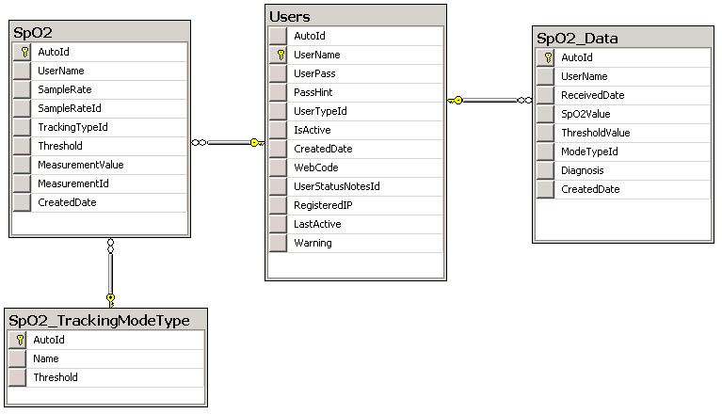

Table **Sp02:** management setting information SpO2

|  |  |  |  |
| --- | --- | --- | --- |
| **No.** | **Field name** | **Data type** | **Notes** |
| 1 | UserName | varchar (50) | Foreign key from table Users |
| 2 | SampleRate | float |  |
| 3 | SampleRateId | int | Foreign key from table UnitTime |
| 4 | TrackingTypeId | int | Foreign key from table SpO2_TrackingModeType |
| 5 | Threshold | float |  |
| 6 | MeasurementValue | float |  |
| 7 | MeasurementId | int | Foreign key from table UnitTime |
| 8 | CreatedDate | datetime |  |

Table **Sp02_Data:** management data SpO2 receive from BS

|  |  |  |  |
| --- | --- | --- | --- |
| **No.** | **Field name** | **Data type** | **Notes** |
| 1 | UserName | varchar (50) | Foreign key from table Users |
| 2 | ReceivedDate | datetime |  |
| 3 | SpO2Value | float |  |
| 4 | ThresholdValue | int |  |
| 5 | ModeTypeId | float | Foreign key from table SpO2_TrackingModeType |
| 6 | Diagnosis | varchar (200) |  |
| 7 | CreatedDate | datetime |  |

**10/** Module **Sleep:** management setting information Sleepand receive data Sleepfrom BS of user

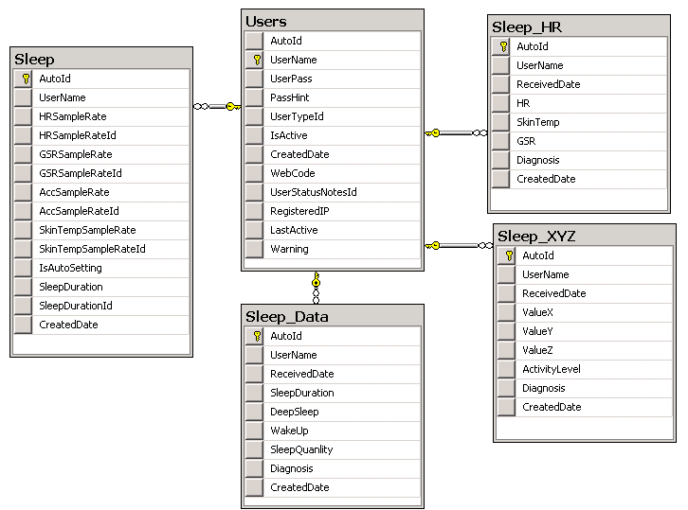

Table **Sleep:** management setting information Sleep

|  |  |  |  |
| --- | --- | --- | --- |
| **No.** | **Field name** | **Data type** | **Notes** |
| 1 | UserName | varchar (50) | Foreign key from table Users |
| 2 | HRSampleRate | float |  |
| 3 | HRSampleRateId | int | Foreign key from table UnitTime |
| 4 | GSRSampleRate | float |  |
| 5 | GSRSampleRateId | int | Foreign key from table UnitTime |
| 6 | AccSampleRate | float |  |
| 7 | AccSampleRateId | int | Foreign key from table UnitTime |
| 8 | SkinTempSampleRate | float |  |
| 9 | SkinTempSampleRateId | int | Foreign key from table UnitTime |
| 10 | IsAutoSetting | bit |  |
| 11 | SleepDuration | float |  |
| 12 | SleepDurationId | int | Foreign key from table UnitTime |
| 13 | CreatedDate | datetime |  |

Table **Sleep_Data:** management receive data Sleepfrom BS of user

|  |  |  |  |
| --- | --- | --- | --- |
| **No.** | **Field name** | **Data type** | **Notes** |
| 1 | UserName | varchar (50) | Foreign key from table Users |
| 2 | ReceivedDate | datetime |  |
| 3 | SleepDuration | float |  |
| 4 | DeepSleep | float |  |
| 5 | WakeUp | float |  |
| 6 | SleepQuanlity | float |  |
| 7 | Diagnosis | varchar (200) |  |
| 8 | CreatedDate | datetime |  |

Table **Sleep_HR:** management receive data HRfrom BS of user

|  |  |  |  |
| --- | --- | --- | --- |
| **No.** | **Field name** | **Data type** | **Notes** |
| 1 | UserName | varchar (50) | Foreign key from table Users |
| 2 | ReceivedDate | datetime |  |
| 3 | HR | float |  |
| 4 | SkinTemp | float |  |
| 5 | GSR | float |  |
| 6 | Diagnosis | varchar (200) |  |
| 7 | CreatedDate | datetime |  |

Table **Sleep_XYZ:** management receive data XYZfrom BS of user

|  |  |  |  |
| --- | --- | --- | --- |
| **No.** | **Field name** | **Data type** | **Notes** |
| 1 | UserName | varchar (50) | Foreign key from table Users |
| 2 | ReceivedDate | datetime |  |
| 3 | ValueX | float |  |
| 4 | ValueY | float |  |
| 5 | ValueZ | float |  |
| 6 | ActivityLevel | float |  |
| 7 | Diagnosis | varchar (200) |  |
| 8 | CreatedDate | datetime |  |

**11/** Module **Stress:** management setting information Stress and receive data Stress from BS of user

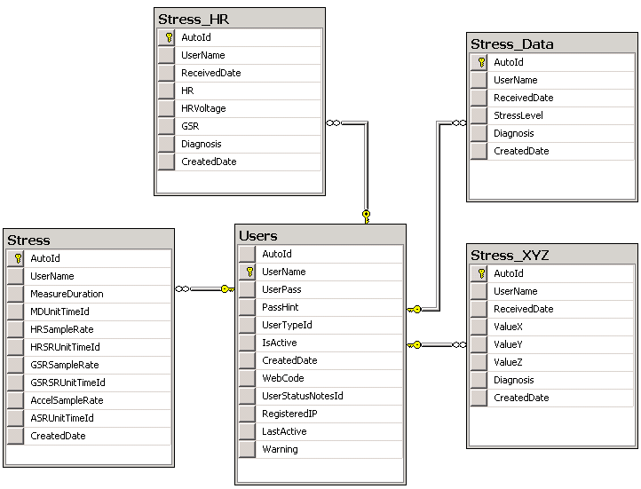

Table **Stress:** management setting information Stress

|  |  |  |  |
| --- | --- | --- | --- |
| **No.** | **Field name** | **Data type** | **Notes** |
| 1 | UserName | varchar (50) | Foreign key from table Users |
| 2 | MeasureDuration | float |  |
| 3 | MDUnitTimeId | int | Foreign key from table UnitTime |
| 4 | HRSampleRate | float |  |
| 5 | HRSRUnitTimeId | int | Foreign key from table UnitTime |
| 6 | GSRSampleRate | float |  |
| 7 | GSRSRUnitTimeId | int | Foreign key from table UnitTime |
| 8 | AccelSampleRate | float |  |
| 9 | ASRUnitTimeId | int | Foreign key from table UnitTime |
| 10 | CreatedDate | datetime |  |

Table **Stress _HR:** management receive data HRfrom BS of user

|  |  |  |  |
| --- | --- | --- | --- |
| **No.** | **Field name** | **Data type** | **Notes** |
| 1 | UserName | varchar (50) | Foreign key from table Users |
| 2 | ReceivedDate | datetime |  |
| 3 | HR | float |  |
| 4 | HRVoltage | float |  |
| 5 | GSR | float |  |
| 6 | Diagnosis | varchar (200) |  |
| 7 | CreatedDate | datetime |  |

Table **Stress _XYZ:** management receive data XYZfrom BS of user

|  |  |  |  |
| --- | --- | --- | --- |
| **No.** | **Field name** | **Data type** | **Notes** |
| 1 | UserName | varchar (50) | Foreign key from table Users |
| 2 | ReceivedDate | datetime |  |
| 3 | ValueX | float |  |
| 4 | ValueY | float |  |
| 5 | ValueZ | float |  |
| 6 | Diagnosis | varchar (200) |  |
| 7 | CreatedDate | datetime |  |

Table **Stress _Data:** management receive data StressLevel from BS of user

|  |  |  |  |
| --- | --- | --- | --- |
| **No.** | **Field name** | **Data type** | **Notes** |
| 1 | UserName | varchar (50) | Foreign key from table Users |
| 2 | ReceivedDate | datetime |  |
| 3 | StressLevel | float |  |
| 4 | Diagnosis | varchar (200) |  |
| 5 | CreatedDate | datetime |  |

**12/** Module **Fertility:** management setting information Fertility and receive data Fertility from BS of user

Table **Fertility:** management setting information Fertility

|  |  |  |  |
| --- | --- | --- | --- |
| **No.** | **Field name** | **Data type** | **Notes** |
| 1 | UserName | varchar (50) | Foreign key from table Users |
| 2 | IsInputAuto | bit |  |

Table **Fertility_DateOfPeriod:** management receive data date of period from BS of user

|  |  |  |  |
| --- | --- | --- | --- |
| **No.** | **Field name** | **Data type** | **Notes** |
| 1 | UserName | varchar (50) | Foreign key from table Users |
| 2 | DateOfPeriod | datetime |  |

Table **Fertility_Temperature:** management receive data Temperature from BS of user

|  |  |  |  |
| --- | --- | --- | --- |
| **No.** | **Field name** | **Data type** | **Notes** |
| 1 | UserName | varchar (50) | Foreign key from table Users |
| 2 | ReceivedDate | datetime |  |
| 3 | Skin | float |  |
| 4 | Ambient | float |  |
| 5 | CreatedDate | datetime |  |

**13/** Module **Position:** management setting information Position and receive data Position from BS of user

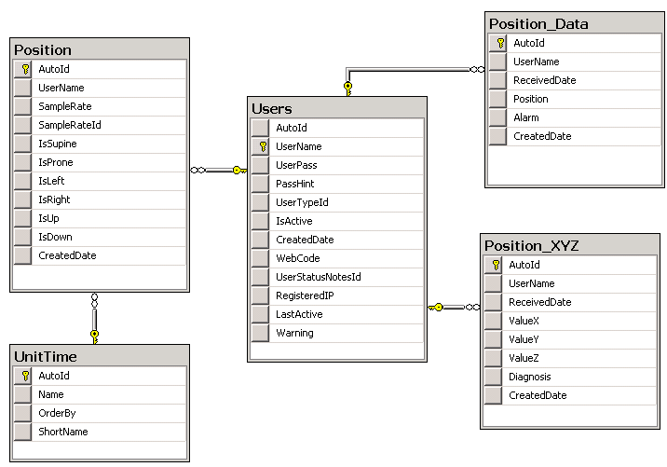

Table **Position:** management setting information Position

|  |  |  |  |
| --- | --- | --- | --- |
| **No.** | **Field name** | **Data type** | **Notes** |
| 1 | UserName | varchar (50) | Foreign key from table Users |
| 2 | SampleRate | float |  |
| 3 | SampleRateId | int | Foreign key from table UnitTime |
| 4 | IsSupine | bit |  |
| 5 | IsProne | bit |  |
| 6 | IsLeft | bit |  |
| 7 | IsRight | bit |  |
| 8 | IsUp | bit |  |
| 9 | IsDown | bit |  |
| 10 | CreatedDate | datetime |  |

Table **Position_Data:** management receive data Position from BS of user

|  |  |  |  |
| --- | --- | --- | --- |
| **No.** | **Field name** | **Data type** | **Notes** |
| 1 | UserName | varchar (50) | Foreign key from table Users |
| 2 | ReceivedDate | float |  |
| 3 | Position | varchar (50) |  |
| 4 | Alarm | varchar (50) |  |
| 5 | CreatedDate | datetime |  |

Table **Position _XYZ:** management receive data XYZfrom BS of user

|  |  |  |  |
| --- | --- | --- | --- |
| **No.** | **Field name** | **Data type** | **Notes** |
| 1 | UserName | varchar (50) | Foreign key from table Users |
| 2 | ReceivedDate | datetime |  |
| 3 | ValueX | float |  |
| 4 | ValueY | float |  |
| 5 | ValueZ | float |  |
| 6 | Diagnosis | varchar (200) |  |
| 7 | CreatedDate | datetime |  |